**Area Calculator**

# Author = Darren Isaacson

# This program will calculate the area of a rectangle.

print("Welcome to the rectangle area calculator")

# Gathering user information

userWidth = float(input("What is the width of your rectangle? "))

userHeight = float(input("What is the height of your rectangle? "))

# Calculating the area of the rectangle

area = userWidth * userHeight

# Displaying output

print("The area of the rectangle is", str(area))

print("end")

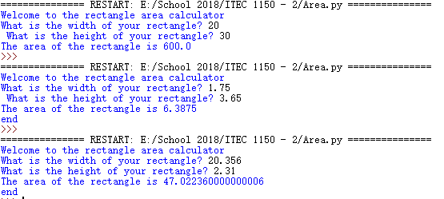

**One Line**

# Author = Darren Isaacson

# This is the one line program.

# This program has print functions that are shown in the output

print("To show off my Python string formatting,\nhere\'s a tab \t and another tab \t and then this string\nwill\n"

"continue on a new line\nthen I\'ll display three double quotes\"\"\" and a single quote\'\nand finally this character\\is a"

"back slash.")

print("end")

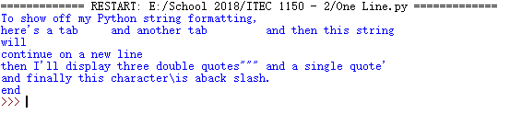

**Sales Tax program**

# Author = Darren Isaacson

# This prorgram is designed to calculate the sales tax of the users purchase

print("Welcome to the sales tax calculator\n")

# Enter in there purchase value

userPurchase = float(input("What was your total purchase today? "))

#Foundating the sales tax to variables

stateTax = 0.05

countyTax = 0.025

# Finding the tax difference and putting them into variables

stateTaxtotal = stateTax * userPurchase

countyTaxtotal = countyTax * userPurchase

# Calculating the total tax

salesTaxtotal = countyTaxtotal + stateTaxtotal

# Calculating the total cost of the purchase with tax

totalCost = salesTaxtotal + userPurchase

# Creating a formated output

print("Your total is going to be: $" + format(totalCost,'.2f'))

print("Here is the serperation of your purchase today!\n")

# Creating a formated table

print("Price\tState Tax\tCounty Tax\tTotal")

print("$" + format(userPurchase,'.2f') + "\t$" + format(stateTaxtotal,'.2f') + "\t\t$" +

format(countyTaxtotal,'.2f') + "\t\t$" + format(totalCost,'.2f')

)

print("\nThanks for Shopping!")

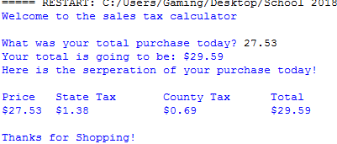

**Math – 1**

# Author = Darren Isaacson

# This progam is for the math test

print(format(7.89,'.0f'))

# No you can not round to 7

print(format(54.345395,'.3f'))

import math

print(math.sqrt(2))

print(math.pi)

print(math.sin(7))

print(format(math.pi,'.3f'))

